A

PRACTICAL TRAINING PROJECT REPORT

ON

(Power BI)

In partial fulfillment of

B.Tech. III yr (Computer Science & Engg.)

Work Carried Out At “Celebal Technologies”

Submitted To: Submitted by:
---------------------- --------------------------

Mrs.Roshna Khalid T Paramjeet Solanki
Assistant Professor (JIET) 18EJICS110
(CSE Department)

Acknowledgment

Any effort becomes successful when there is the effect
of synergy the concept that two and two make more
than four. This project has also the effect of synergy,
without prejudice to my own contribution.

I am appreciative of Jodhpur Institute of Engineering
and Technology and those people who cooperate with
me to prepare this training project. It is my privilege
that I had the opportunity to do an training at
Celebal Technologies.

I would like to those all who either directly or
indirectly contributed to this project.

At first, I express my deep gratefulness Mr. Sanjay Bhandari sir who gave me the
opportunity to allow me to work in this organization areas.

Mrs. Roshna Khalid (Mentor) without their effort, it
would be impossible to bring this to the light.
Finally, I express my deep gratefulness to my
Team Member Mr.Piyush Bhargav.
I am very much pleased to all of them for me helping
me to complete this project.

Preface

We are living in the age of technological progression. Digital advancements have completely revolutionized our everyday lives, and one of the largest impacts felt has been in the business world. Companies now have access to data-driven tools and strategies that allow them to learn more about their customers and themselves than ever before, but not everyone is taking advantage of them. Today we’re going to breakdown Business Intelligence and why it’s crucial to the success and longevity of your organization.

Before we jump into the importance, we must first understand Business Intelligence and how it applies to your company’s strategic initiatives. The term Business Intelligence (BI) refers to the technologies, applications, strategies, and practices used to collect, analyze, integrate, and present pertinent business information. The entire purpose of Business Intelligence is to support and facilitate better business decisions. BI allows organizations access to information that is critical to the success of multiple areas including sales, finance, marketing, and a multitude of other areas and departments. Effectively leveraging BI will empower your business with increased actionable data, provide great insights into industry trends, and facilitate a more strategically geared decision-making model.
To illustrate BI in action, here are a few departmental specific examples of insights and benefits that can come from its adoption and application:
- Human Resources: HR can tremendously benefit from the implementation of Business Intelligence utilizing employee productivity analysis, compensation and payroll tracking, and insights into employee satisfaction.
- Finance: Business Intelligence can help finance departments by providing invaluable and in-depth insights into financial data. The application of BI can also help to track quarterly and annual budgets, identify potential problem areas before they cause any negative impacts, and improve the overall organizational business health and financial stability.
- Sales: Business Intelligence can assist your company’s sales force by providing visualizations of the sales cycle, in-depth conversion rates analytics, as well as total revenue analysis. BI can help your sales team to identify what’s working as well as points of failure which can result in dramatically improved sales performance.
- Marketing: BI provides the marketing department with a convenient way to view all current and past campaigns, the performance and trends of those campaigns, a breakdown of the cost per lead and the return on investment, site traffic analytics, as well as a multitude of other actionable pieces of information.
- Executive Leadership: Plain and simple, Business Intelligence allows organizations to reduce costs by improving efficiency and productivity, improving sales, and revealing opportunities for continuous improvement. Business Intelligence allows members of Executive Leadership to more easily measure the organization’s pulse by removing gray areas and eliminating the need to play the guessing game on how the company is doing.
Now you know what Business Intelligence is, what it’s capable of, but the question remains; why is Business Intelligence so important to modern-day organizations? The main reasons to invest in a solid BI strategy and system are:
- Gain New Customer Insights: One of the primary reasons companies are investing their time, money, and efforts into Business Intelligence is because it gives them a greater ability to observe and analyze current customer buying trends. Once you utilize BI to understand what your consumers are buying and the buying motive, you can use this information to create products and product improvements to meet their expectations and needs and, as a result, improve your organization’s bottom-line.
- Improved Visibility: Business Intelligent organizations have better control over their processes and standard operating procedures, as the visibility of these functions is improved by a BI system. The days of skimming through hundreds of pages of annual reports to assess performance are long gone. Business Intelligence illuminates all areas of your organization helps you to readily identify areas for improvement and allow you to be prepared instead of reactive.
- Actionable Information: An effective Business Intelligence system serves as a means to identify key organizational patterns and trends. A BI system also allows you to understand the implications of various organizational processes and changes, allowing you to make informed decisions and act accordingly.
- Efficiency Improvements: BI Systems help improve organizational efficiency which consequently increases productivity and can potentially increase revenue. Business Intelligence systems allow businesses to share vital information across departments with ease, saving time on reporting, data extraction, and data interpretation. Making the sharing of information easier and more efficient permits organizations to eliminate redundant roles and duties, allowing the employees to focus on their work instead of focusing on processing data.
- Sales Insight: Sales and marketing teams alike want to keep track of their customers, and most utilize Customer Relationship Management (CRM) application to do so. CRMs are designed to handle all interactions with customers. Because they house all customer communications and interactions, there is a wealth of data and information that can be interpreted and used to strategic initiatives. BI systems help organizations with everything from identifying new customers, tracking and retaining existing ones, and providing post-sale services.
- Real-Time Data: When executives and decision-makers have to wait for reports to be compiled by various departments, the data is prone to human error and is at risk of being outdated before it’s even submitted for review. BI systems provide users with access to data in real-time through various means including spreadsheets, visual dashboards, and scheduled emails. Large amounts can be assimilated, interpreted, and distributed quickly and accurately when leveraging Business Intelligence tools.
- Competitive Advantage: In addition to all of these great benefits, Business Intelligence can help you gain insight into what your competitors are doing, allowing your organization to make educated decisions and plan for future endeavors.

Table of Contents

Acknowledgment 8
Preface 9
1. Table of Contents 10
2. Introduction 11
3. Company/Organization Overview 13
3.1 Company/Organization Technology area 13
3.2 Details about the training guide/mentor at the company/organization. 13
3.3 Address/Contact Information of company/organization and guide. 13
4. Technology used in Project 14
5. Technical Details of Project 15
5.1 Architectural Overview 15
5.2 Functional Block Diagram 15
5.3 Flow Chart 15
5.4 Functions/Modules Details 15
5.5 Pseudo Code/ Algorithm 15
6. Applications 16
7. Future Work 17
8. Conclusion 18

Introduction

Power BI is a Data Visualization and Business Intelligence tool that converts data from different data sources to interactive dashboards and BI reports. Power BI suite provides multiple software, connector, and services - Power BI desktop, Power BI service based on Saas, and mobile Power BI apps available for different platforms. These set of services are used by business users to consume data and build BI reports.
Power BI desktop app is used to create reports, while Power BI Services (Software as a Service - SaaS) is used to publish the reports, and Power BI mobile app is used to view the reports and dashboards.

CELEBAL TECHNOLOGIES 

Celebal Technologies is a premier software services company in the field of Data Science, Big Data, and Enterprise Cloud. We help you achieve a competitive advantage with intelligent data solutions, built using cutting-edge technology. Our core offerings are around Cloud Innovation, Supply Chain Analytics, Chat Bots, Power Platforms, and Data Analytics. Our solutions can help you accelerate decision-making and take giants leaps in your digital transformation journeys.

Our mission is to make data simple and easy to understand for all organizations. We are committed to providing solutions powered by modern cloud and artificial intelligence that integrate with traditional enterprise software. Our tailor-made solutions help enterprises maximise productivity, improve speed and accuracy.

Our Team is made up of highly motivated and talented professionals, who understand the core value of modern analytics over traditional enterprise. We follow the concept of non-hierarchical work culture, empowering every individual in the organization to do their best. We are always on the lookout for skilled professionals who believe in integrity and respect, and enjoy working in a fast-paced and autonomous environment.


Co-Founder – Anirudh Kala (Director)
LinkedIn Profile - https://www.linkedin.com/in/anirudhkala/


Co-Founder – Anupam Gupta (Head of US Operations)
LinkedIn Profile - https://www.linkedin.com/in/anupamgupta1/

Our Partners –

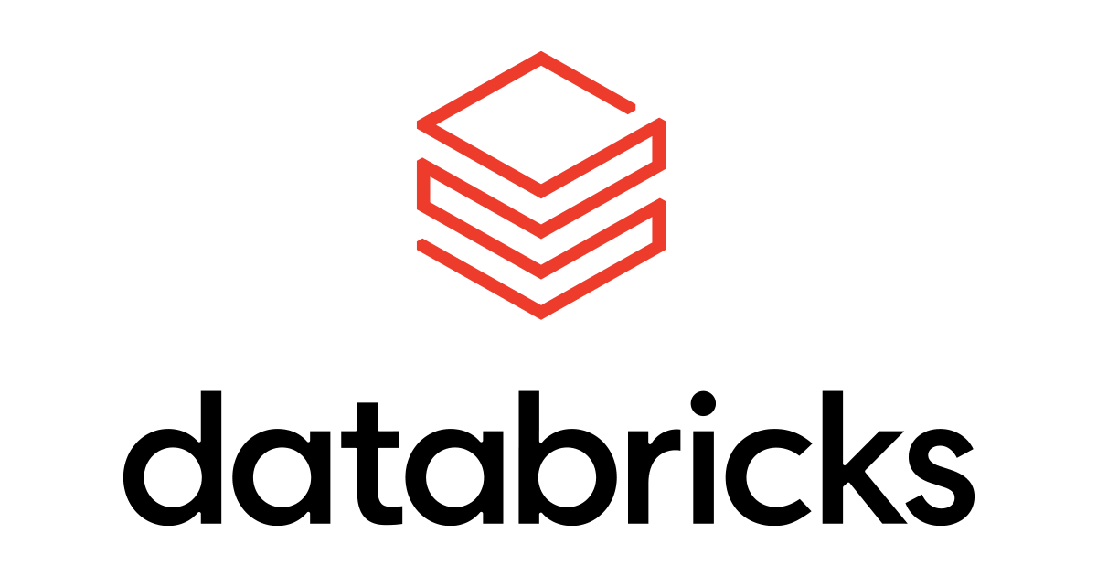

Technology used in Project
Power BI

Power BI is a collection of software services, apps, and connectors that work together to turn your unrelated sources of data into coherent, visually immersive, and interactive insights. Your data may be an Excel spreadsheet, or a collection of cloud-based and on-premises hybrid data warehouses. Power BI lets you easily connect to your data sources, visualize and discover what's important, and share that with anyone or everyone you want.

The parts of Power BI
Power BI consists of several elements that all work together, starting with these three basics:
- A Windows desktop application called Power BI Desktop.
- An online SaaS (Software as a Service) service called the Power BI service.
- Power BI mobile apps for Windows, iOS, and Android devices.

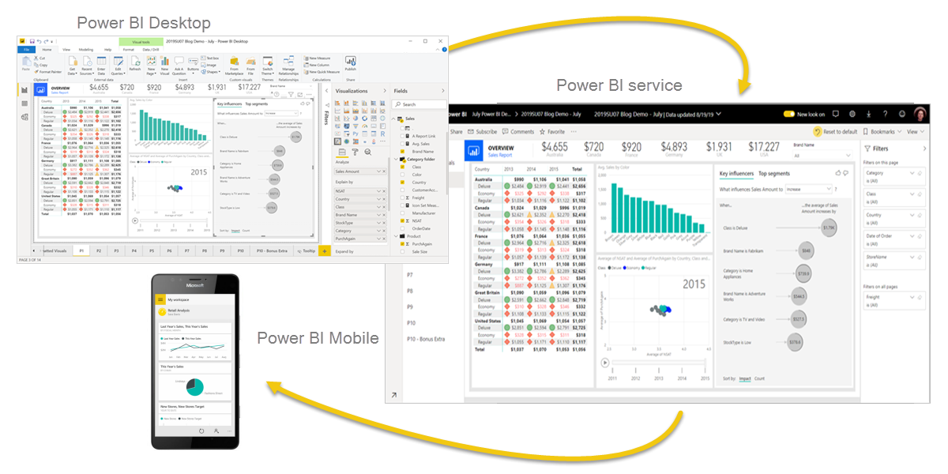

These three elements—Power BI Desktop, the service, and the mobile apps—are designed to let you create, share, and consume business insights in the way that serves you and your role most effectively.
Beyond those three, Power BI also features two other elements:
- Power BI Report Builder, for creating paginated reports to share in the Power BI service. Read more about paginated reports later in this article.
- Power BI Report Server, an on-premises report server where you can publish your Power BI reports, after creating them in Power BI Desktop. Read more about Power BI Report Server later in this article.

Introduction to creating measures using DAX in Power BI

Data Analysis Expressions (DAX) is a programming language that is used throughout Microsoft Power BI for creating calculated columns, measures, and custom tables. It is a collection of functions, operators, and constants that can be used in a formula, or expression, to calculate and return one or more values. You can use DAX to solve a number of calculations and data analysis problems, which can help you create new information from data that is already in your model.

In Power BI, you can use different calculation techniques and functions to create measures or calculated columns. Primarily, you will be able to achieve the same result by using these techniques; however, the key is to know how and when to apply them. By having a basic understanding of when and how to use which technique, you will be able to create robust and high-performance data models.

Technical Details of Project

Project - Financial Year Data

Overview - The Data set is about the Financial data in which we have to work upon the given statement given by the company and analyze the data with the help of the DAX Formulas.

Description - Apply following Dax in Financial Data Set.

1- Total Quantity Sold
2- Quantity Sold Last Month
3- Quantity Sold Last Year
4- Average Quantity Sold per Day
5- Quantity Sold in "Germany" and "Dell" & "HP"
6- Quantity Sold Two Months Ago
7- Quantity Sold Two Quarters Ago
8- Last Month Profit
9- Profit 2 Month Ago
10- Last Month Cumulative Profit
11- Cumulative Profit 2 Month Ago
12- Total Profit running total in Date.
13- Apply Currency Conversion in it.
14- How to apply the Fiscal Year.

Using This Measure below Given Data Visualization Snapshots.
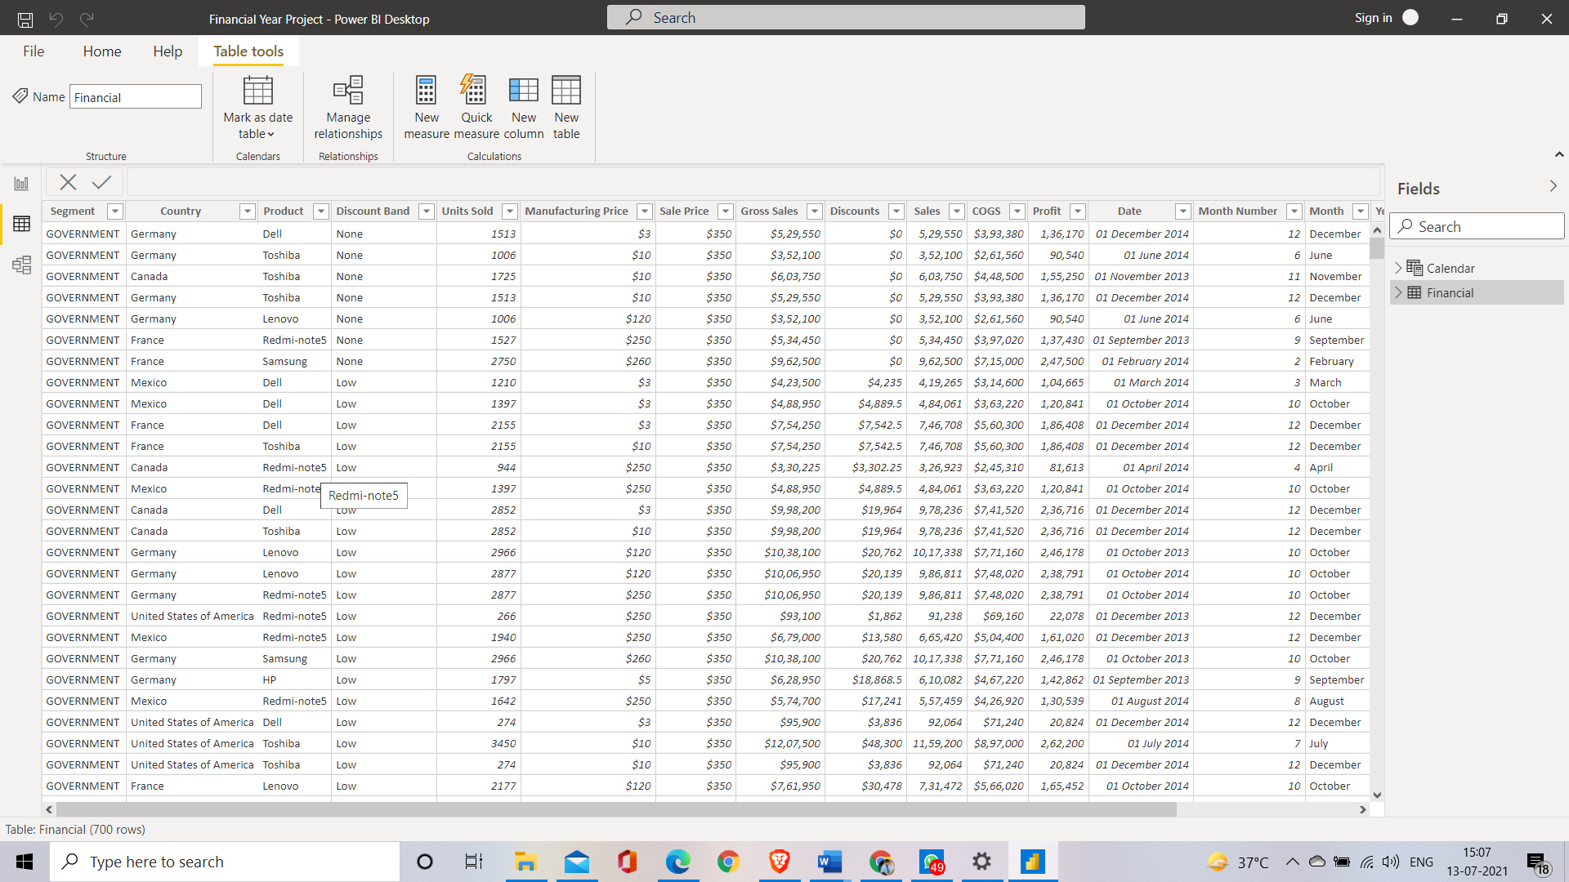

Financial Data Set

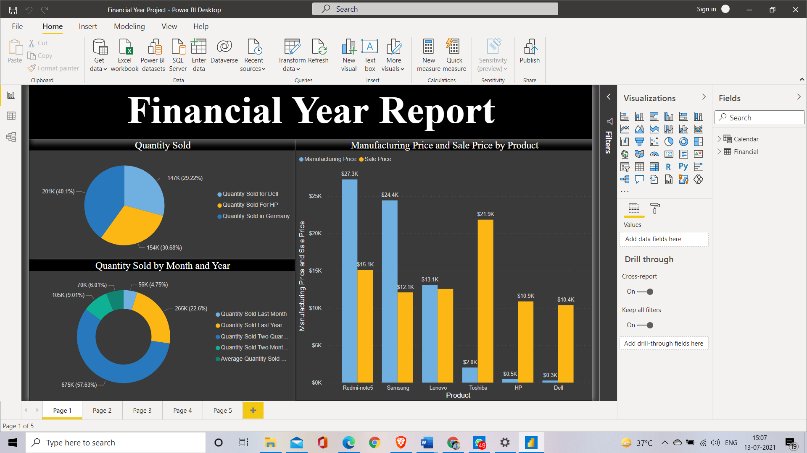

Data Visualization Page 1

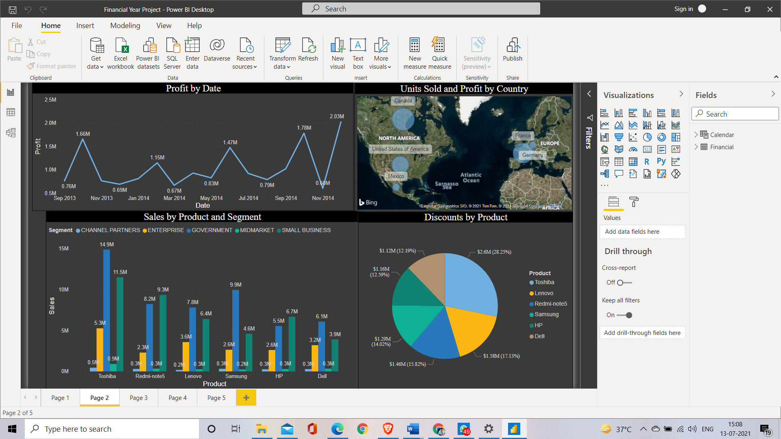

Data Visualization Page 2

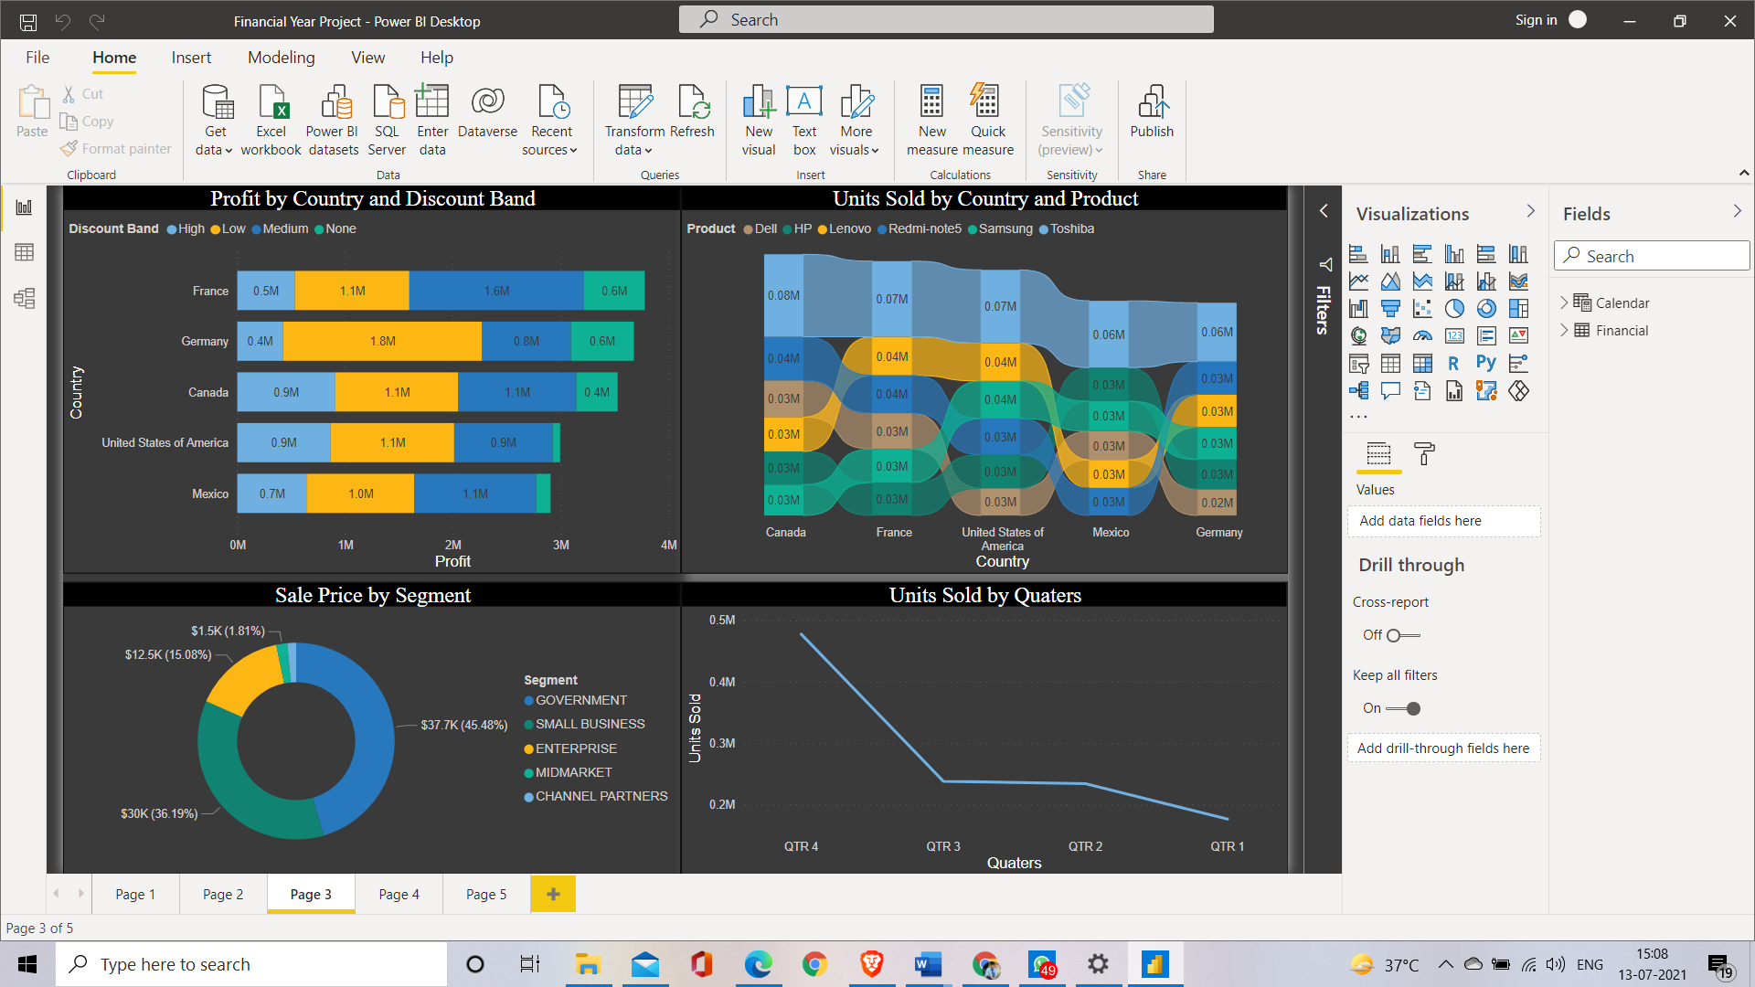

Data Visualization Page 3

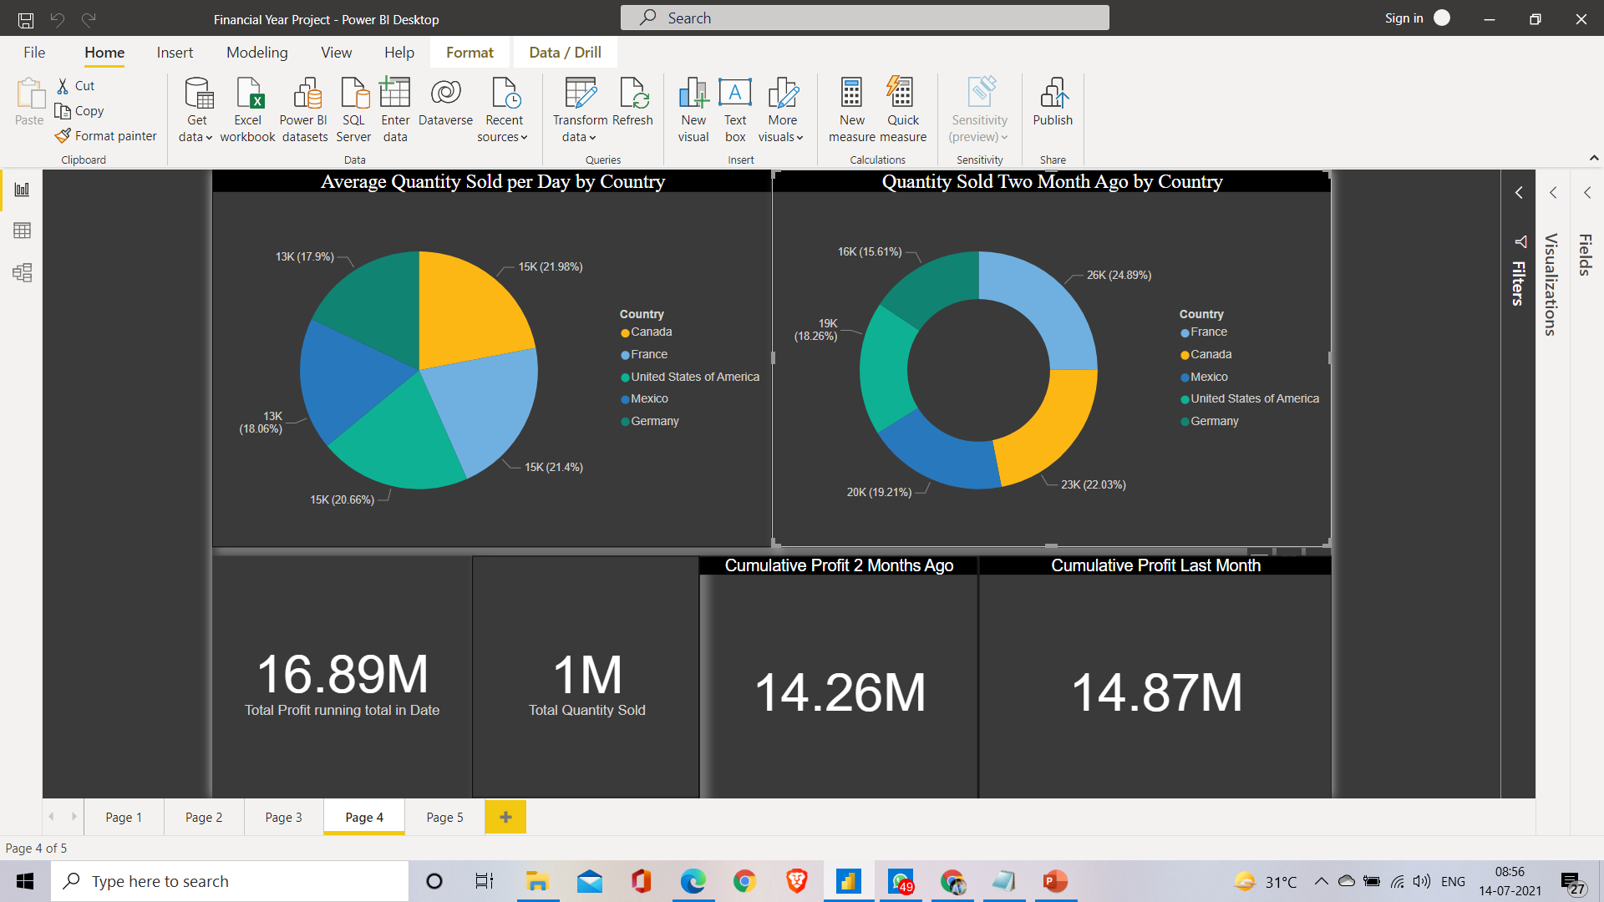

Data Visualization Page 4

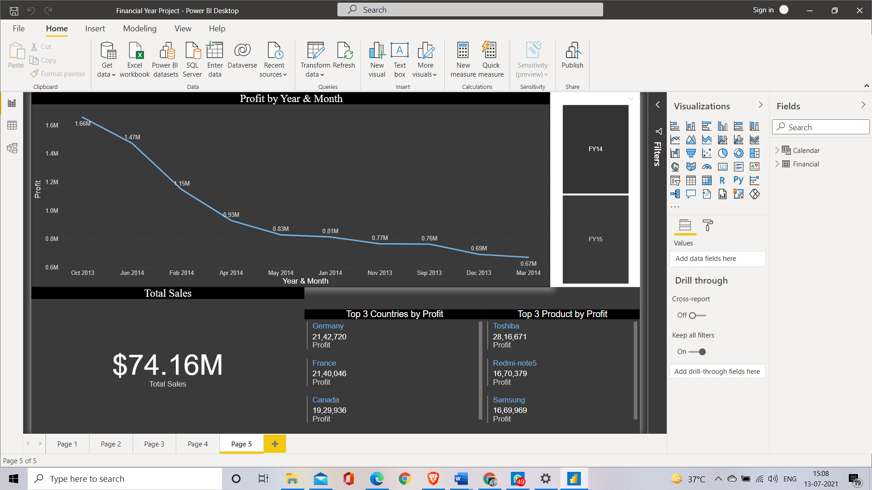

Data Visualizations Page 5

Applications
6 Business Application for Microsoft Power BI.
Your organization works with a lot of data, but if you have a hard time connecting it to important insights, you aren’t maximizing its value. Microsoft Power BI helps you fix this problem through a powerful business intelligence tool that focuses on visualization. You don’t have to try hard to understand spreadsheet columns demanding your attention. Instead, you get clear charts, graphs, diagrams and other reporting visuals. You identify trends, discover patterns and quickly get up to speed on new data sets. Here are a few ways Microsoft Power BI can work for your organization.

1. Automate KPIs in Microsoft Power BI
You have important key performance indicators (KPIs) scattered across multiple applications. You can’t draw conclusions from these metrics when they’re siloed off in individual software. Power BI brings this data together into one panel, so you have an organization-wide view of the information that matters.

2. Visualize Sales Versus Marketing Leads
Do you have problems with your sales team meeting their quota? The problem may not originate from their department – it could be the quality or quantity of leads from marketing. Even your best account representatives can’t do their job properly if they don’t start with the right prospects. Microsoft Power BI lets you visualize the relationship between these two critical metrics.

3. Conduct a Marketing Health Check
You invest heavily in your online marketing to attract customers while they’re researching solutions to their unique problems, but they’re falling out of the funnel before they convert. What’s going wrong between their click through and the sale? Power BI brings this relevant data into a chart so you can track user behavior throughout their journey. Your campaign may have significant problems or simply missed the mark with the target demographic.

4. Gain a Real-Time Look at Your Company’s Financial Performance
Financial setbacks have a long-lasting impact on your organization, especially if it’s completely out of nowhere. Microsoft Power BI gives you insight into the company’s performance at multiple levels. You can look into a team’s profitability, your top-selling products, the revenue generated by a particular department and many other views. This data comes into Power BI in real-time, so sudden drops get immediate attention. You get the chance to fix the problem before it snowballs into a massive concern.

5. Create Consistent Reporting Standards
How many software packages exist in your organization? Every department from accounting to sales relies on specialty applications for their day-to-day job duties. You don’t always get a reporting feature in these programs, and if you do, the format varies significantly from app to app. Using Microsoft Power BI to pull in data and generate reports gives you consistent standards across the organization. It takes less time for managers to understand the information when it’s presented in the same format and style every time.

6. Stay Ahead of Inventory Shortages
Does your business work with physical inventory, whether you’re selling products to the general public or you need to keep track of your office’s printer paper? Power BI stays on top of your inventory numbers, so you know when to bring in more units, the sell-through or usage rate and other critical information.
Your first step to getting the most out of this solution is making sure you supply complete data. Clean and robust data ensures you’re getting accurate information and insights from Power BI. This flexible business intelligence tool has a place in every business.

Future Work

The demand for BI (Business Intelligence) and Decision Making will not dip in the near future. Definitely, no other BI tool is going to overcome Power BI’s dominance in the next ten years. Also, Power BI is easy to use and excellent for data visualization.
Moreover, the product is a Microsoft product. What makes it potent is that a range of products from Microsoft are already global leaders. Integration with Power BI is not only essential but also it augurs well for its users as the brand ensures it is here to stay with adding features every week at a random pace.
How has Power BI Evolved?
The genesis of Power BI happened in July 2015 when it evolved out of Sharepoint’s key feature. Slowly it graduated out of its shareable feature to a full-fledged cloud-based data analytics and visualization service.
If you recall, in 2010 Microsoft introduced Power Pivot in Excel, a visualization tool called Power view and Power Maps for representing spatial data. Now, you have it all in Power BI along with other excellent features like Natural Language Query QnA.
Today, Power BI provides the users to create reports and interactive cloud-based visual dashboards without the help of an administrator or any information analyst. The service is available for both desktop and cell phones. Since its inception in 2014, Microsoft has heavily focused on the evolution of Power Bi and today it has emerged as the front-runner.
If you are looking at Power BI as just another cloud option to Microsoft Excel’s Pivot tables/charts or a mere data visualization function, you will be surprised by how much more it does. As a user, you can slice data into various analytics with the help of Power BI. Microsoft over time has strived to bring many of their features of various programs under one superior data visualization platform.
Why Power BI became an Emerging Leader in Business Analytics:
Today, you can achieve so much with Power BI. If you want to design your dashboards, upload them online and allow others to access them without hassles, Power BI can do it for you. Some of the attributes that Power BI scores over others are:
Cheapest Option:
The Gartner Group considers this platform to be the most inexpensive solution available in the market today. They approximate that it is about 80% cheaper than other cloud platforms. Moreover, Power BI Desktop option is free to use.
Multiple Source Connectors:
One of its most powerful attributes is Power BI can connect to any cloud-based data source. With more than 70 connectors, report packages and built-in dashboards by Microsoft itself and others like Excel, Quickbooks, GitHub, MailChimp , Salesforce, Zendesk, Google Analytics etc., and more on the way, Power BI easily connects to all of these data sources easily.
Easy to Use:
With Power BI, users don’t have to rely on their analyst or data administrator to access or process data. They can learn it with ease in no time. Imagine if the employees can analyze data and create reports, how good it is for the companies to make quick and effective business decisions.
Interactive Visual Dashboards:
Power BI helps you in drilling down your available data for deeper insights. You can easily access and analyze data from various sources and integrated them seamlessly. The custom-made visualization dashboards can present the data in colorful and unique ways for your consideration.
Easily Accessible to All:
You can access the dashboards from anywhere. Their apps are published for all devices. You can even access them on your Android, Windows and Apple phones and tablets.
Data Sharing:
You can easily save hours pulling out data from innumerable sources and then re-compiling them. Mailing them all to various destinations can be cumbersome too.
With Power BI, you can quickly set a schedule to refresh data. The data then automatically gets updated with periodic refreshes, thus saving tons of time and money for an organization.
Language Queries:
The inbuilt intelligence in Power BI handles many queries in simple language. If you ask a question, this tool presents data based on your natural language query. It creates and presents data in a visual form to you for better comprehension. Also, it eliminates the process of waiting for an analyst to come out with the reports.
Is Power BI the Future of Excel?
Microsoft Excel has come a long way. With the inclusion of Power Query, Power Pivot, Power View and Power Maps, you can today integrate, cleanup and manipulate any data. With the Pivot tables and the formulae already popular, let us check out how Power Bi is empowering Excel with its advanced interactive tools.
Power BI actually enhances the functionality of Microsoft Excel manifold. It not only analyses and represents the data visually but also it makes the sharing process smoother across all devices.
Unlike the Excel analytics tools, where you connect outside its domain to functions like Power Query, Power Pivot and Power view in separate windows. And then take the help of tools like Excel, HTML5, SharePoint to share these complex data. Wit Power BI you can avoid these unnecessary steps with one cohesive application.
Today, Power BI has taken a significant leap forward in business intelligence service solution. Excel which was once the leader has to take the help of tools like Tableau but feels cramped for doing a lot of outside third party integrations. Though Excel provides powerful analysis to any kind of data, Power BI enhances it with its interactive tool. You can now quickly scan and find key insights into the data and represent them in impressive visual forms.
Today it has nearly a million users at more than 50000 companies around the globe. Because of its speed every week new features added to this powerful platform.
The Bottom Line:
When there is a demand for a user-friendly tool for data analytics and business intelligence. With a strong brand name of Microsoft behind it and many powerful features like easy integration to popular point solution and interactive visual dashboards. I see no point in harping over its acceptability in the future.
Moreover, it is easy to use and every week you see a new feature popping inside. When you can view it from your cell phone from anywhere, and with the demand for business analytics on the rise, do you think the growth of Power BI can be stopped?

Is Power BI as a Good Career Path?
When we know that the future of Power BI is strong for the next decade or two, is it a good career path for you?
The above question can only be answered if you –
- Like to manipulate data, charts, graphs, and love to play with visual models.
- Are curious enough to dig deep into data to unravel valuable insights
- Strive towards making better business decisions by analyzing a set of data.
- Good at pulling out the right information from other key data sources.

Conclusion

- We have conclude the financial year of a business by calculating different measure and different graph.

- Conclusion through this project are different way in context of learning we have a lot new thing through making measure and trying out new graph which suites the visualization of data .In context for real world ,Form working like a team and solving the problem that where given by the mentor to Making the visualization look more great as firstly learn how to work in small team.

- This project simple conclude that through the same model we can apply to any business financial year and GST a major insights that how there business is working and what insights form a power bi can give the can increase there sales or increase there business.

10. References

  - https://powerbi.microsoft.com/en-us/

  - https://www.celebaltech.com/aboutus

  - https://docs.microsoft.com/en-us/dax/

  - https://docs.microsoft.com/en-us/learn/modules/create-measures-dax-power-bi/#:~:text=Data%20Analysis%20Expressions%20(DAX)%20is,return%20one%20or%20more%20values.

  - https://www.linkedin.com/in/anirudhkala/

  - https://www.linkedin.com/in/anupamgupta1/

  - https://analytiks.co/why-business-intelligence-is-important/

